DAY 5:SELENIUM WEBHANDLERS

**TASK 01:-**

package com.day5;

import org.openqa.selenium.By;

import org.openqa.selenium.WebDriver;

import org.openqa.selenium.WebElement;

import org.openqa.selenium.chrome.ChromeDriver;

import org.openqa.selenium.chrome.ChromeOptions;

import org.openqa.selenium.interactions.Actions;

import io.github.bonigarcia.wdm.WebDriverManager;

public class task1 {

public static void main(String[] args) {

// TODO Auto-generated method stub

WebDriverManager.chromedriver().setup();

ChromeOptions co=new ChromeOptions();

co.addArguments("--remote-allow-origins=*");

WebDriver driver=new ChromeDriver(co);

driver.get("https://demoqa.com/droppable/");

Actions a=new Actions(driver);

WebElement source_ele=driver.findElement(By.id("draggable"));

WebElement dest_ele=driver.findElement(By.id("droppable"));

a.clickAndHold(source_ele).release(dest_ele).build().perform();

a.dragAndDrop(source_ele, dest_ele).build().perform();

}

}

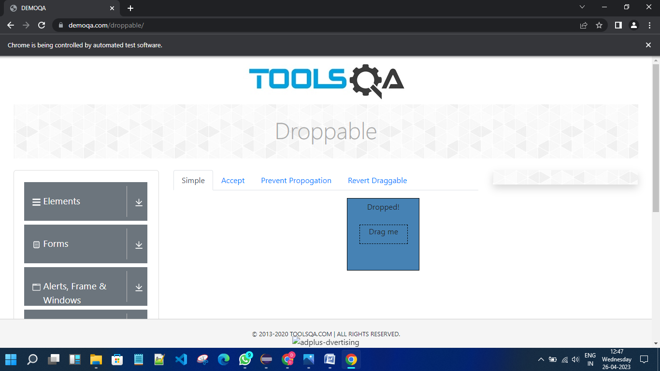

**TASK 02:-**

package com.day5;

import org.openqa.selenium.By;

import org.openqa.selenium.WebDriver;

import org.openqa.selenium.WebElement;

import org.openqa.selenium.chrome.ChromeDriver;

import org.openqa.selenium.chrome.ChromeOptions;

import org.openqa.selenium.interactions.Actions;

import io.github.bonigarcia.wdm.WebDriverManager;

public class task2 {

public static void main(String[] args) {

// TODO Auto-generated method stub

WebDriverManager.chromedriver().setup();

ChromeOptions co=new ChromeOptions();

co.addArguments("--remote-allow-origins=*");

WebDriver driver=new ChromeDriver(co);

driver.get("https://jqueryui.com/droppable/");

driver.switchTo().frame(0);

Actions a=new Actions(driver);

WebElement source_ele=driver.findElement(By.id("draggable"));

WebElement dest_ele=driver.findElement(By.id("droppable"));

a.clickAndHold(source_ele).release(dest_ele).build().perform();

a.dragAndDrop(source_ele, dest_ele).build().perform();

}

}

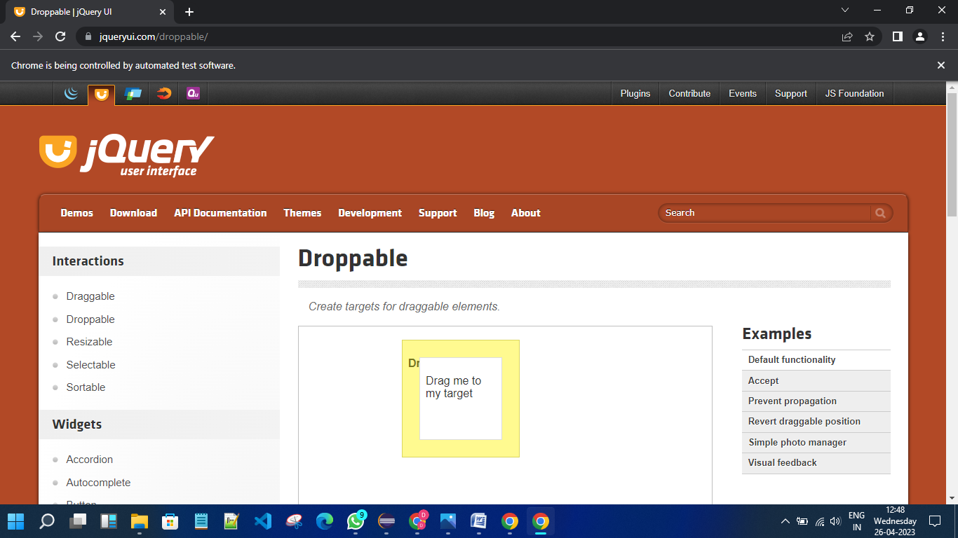

**TASK 03:-**

package com.day5;

import org.openqa.selenium.Alert;

import org.openqa.selenium.By;

import org.openqa.selenium.WebDriver;

import org.openqa.selenium.WebElement;

import org.openqa.selenium.chrome.ChromeDriver;

import org.openqa.selenium.chrome.ChromeOptions;

import io.github.bonigarcia.wdm.WebDriverManager;

public class task3 {

public static void main(String[] args) {

// TODO Auto-generated method stub

WebDriverManager.chromedriver().setup();

ChromeOptions co=new ChromeOptions();

co.addArguments("--remote-allow-origins=*");

WebDriver driver=new ChromeDriver(co);

driver.get("https://demo.guru99.com/test/delete_customer.php");

WebElement fname=driver.findElement(By.xpath("/html/body/form/table/tbody/tr[2]/td[2]/input"));

fname.sendKeys("401");

WebElement submit_btn=driver.findElement(By.name("submit"));

submit_btn.click();

Alert alert1=driver.switchTo().alert();

alert1.dismiss();

fname.clear();

fname.sendKeys("402");

submit_btn.click();

Alert alert2=driver.switchTo().alert();

alert2.accept();

Alert alert3=driver.switchTo().alert();

String txt=alert3.getText();

alert3.accept();

}

}

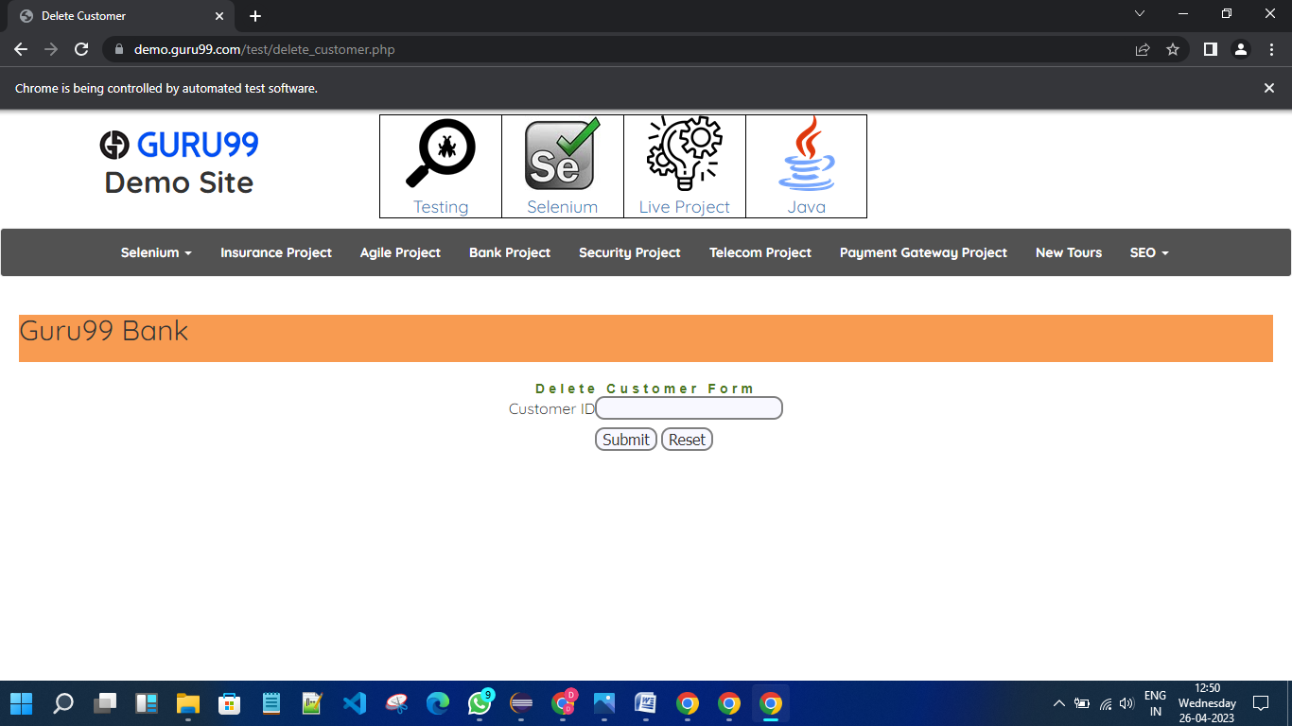

**TASK 04:-**

package com.day5;

import org.openqa.selenium.By;

import org.openqa.selenium.JavascriptExecutor;

import org.openqa.selenium.Keys;

import org.openqa.selenium.WebDriver;

import org.openqa.selenium.WebElement;

import org.openqa.selenium.chrome.ChromeDriver;

import org.openqa.selenium.chrome.ChromeOptions;

import io.github.bonigarcia.wdm.WebDriverManager;

public class task4 {

public static void main(String[] args) throws InterruptedException

{

WebDriverManager.chromedriver().setup();

ChromeOptions co = new ChromeOptions();

co.addArguments("--remote-allow-origins=*");

WebDriver driver = new ChromeDriver(co);

driver.get("https://www.abhibus.com/bus-ticket-booking");

driver.manage().window().maximize();

WebElement from = driver.findElement(By.xpath("//*[@id=\"source\"]"));

from.sendKeys("Coimbatore");

Thread.sleep(3000);

from.sendKeys(Keys.ENTER);

WebElement to = driver.findElement(By.xpath("//*[@id=\"destination\"]"));

to.sendKeys("Tiruppur");

Thread.sleep(3000);

to.sendKeys(Keys.ENTER);

WebElement date = driver.findElement(By.xpath("//*[@id=\"datepicker1\"]"));

date.click();

JavascriptExecutor js = (JavascriptExecutor)driver;

js.executeScript("arguments[0].setAttribute('value','28-04-2023')", date);

WebElement search = driver.findElement(By.xpath("//*[@id=\"seo_search_btn\"]"));

search.click();

}

}

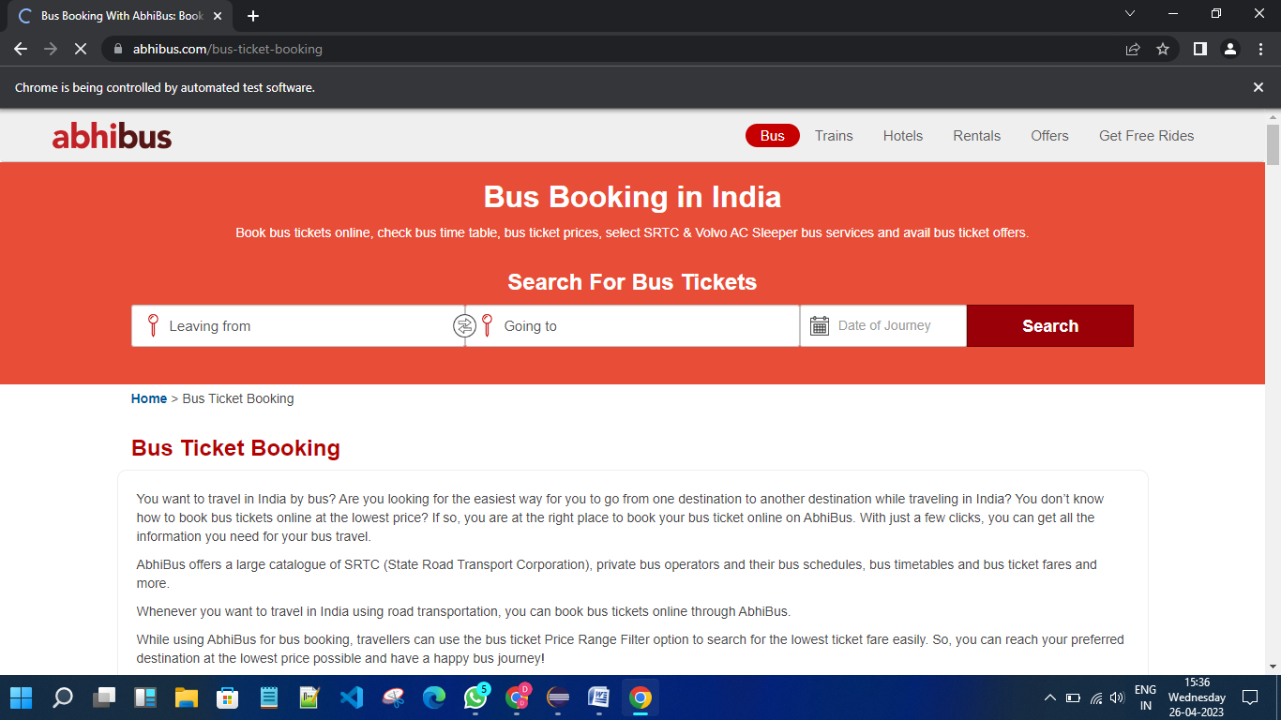

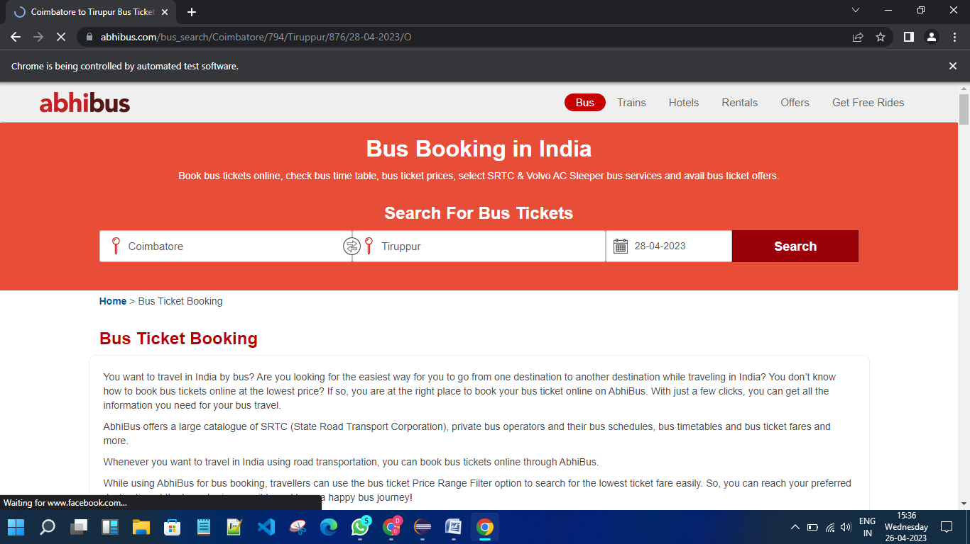

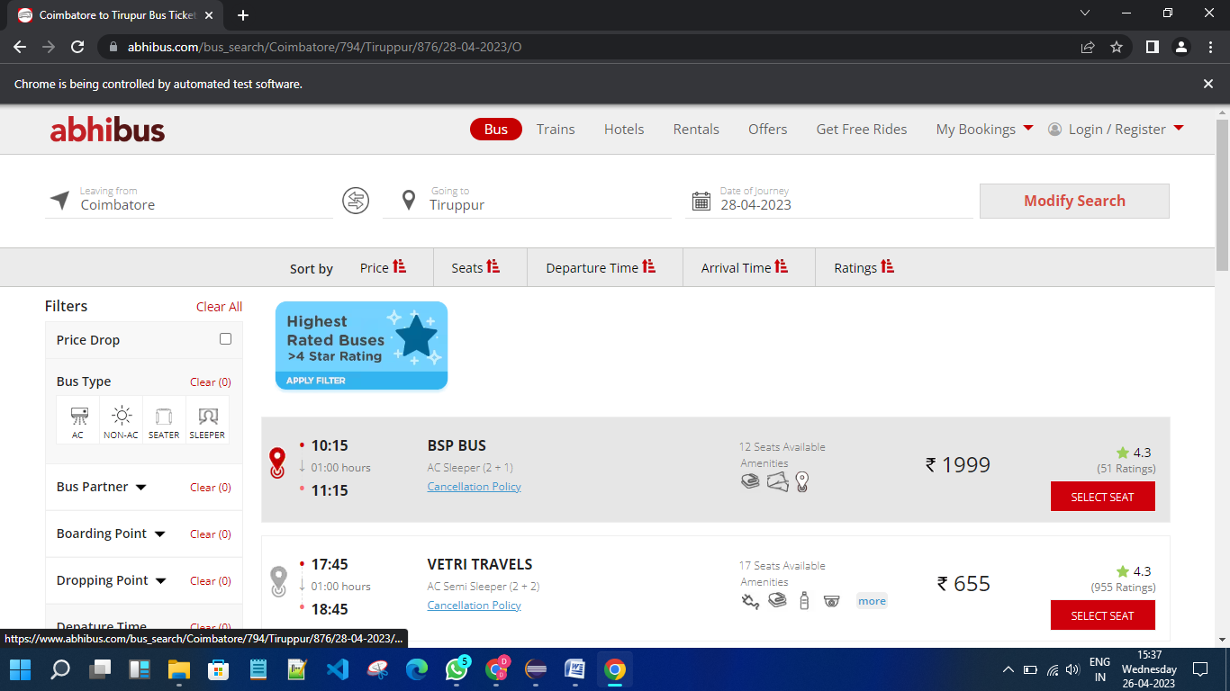

**TASK 05:-**

package day5;

import java.util.Set;

import org.openqa.selenium.By;

import org.openqa.selenium.Keys;

import org.openqa.selenium.WebDriver;

import org.openqa.selenium.WebElement;

import org.openqa.selenium.WindowType;

import org.openqa.selenium.chrome.ChromeDriver;

import org.openqa.selenium.chrome.ChromeOptions;

import io.github.bonigarcia.wdm.WebDriverManager;

public class task5 {

public static void main(String[] args) {

WebDriverManager.chromedriver().setup();

ChromeOptions co=new ChromeOptions();

co.addArguments("--remote-allow-origins=*");

WebDriver driver=new ChromeDriver(co);

driver.get("https://www.google.com");

driver.manage().window().maximize();

WebElement search = driver.findElement(By.xpath("//*[@id=\"APjFqb\"]"));

search.sendKeys("Apple",Keys.ENTER);

String parent=driver.getWindowHandle();

System.out.println(parent);

System.out.println(driver.getTitle());

driver.switchTo().newWindow(WindowType.TAB);

driver.get("https://www.google.com");

driver.manage().window().maximize();

WebElement search2 = driver.findElement(By.xpath("//*[@id=\"APjFqb\"]"));

search2.sendKeys("Selenium",Keys.ENTER);

System.out.print("\n"+driver.getWindowHandle());

System.out.println("\n"+driver.getTitle());

driver.switchTo().newWindow(WindowType.TAB);

driver.get("https://www.google.com");

driver.manage().window().maximize();

WebElement search3 = driver.findElement(By.xpath("//*[@id=\"APjFqb\"]"));

search3.sendKeys("Cucumber",Keys.ENTER);

System.out.print("\n"+driver.getWindowHandle());

System.out.println("\n"+driver.getTitle());

Set<String>s=driver.getWindowHandles();

System.out.println("Number of windows opened = "+s.size());

}

}

